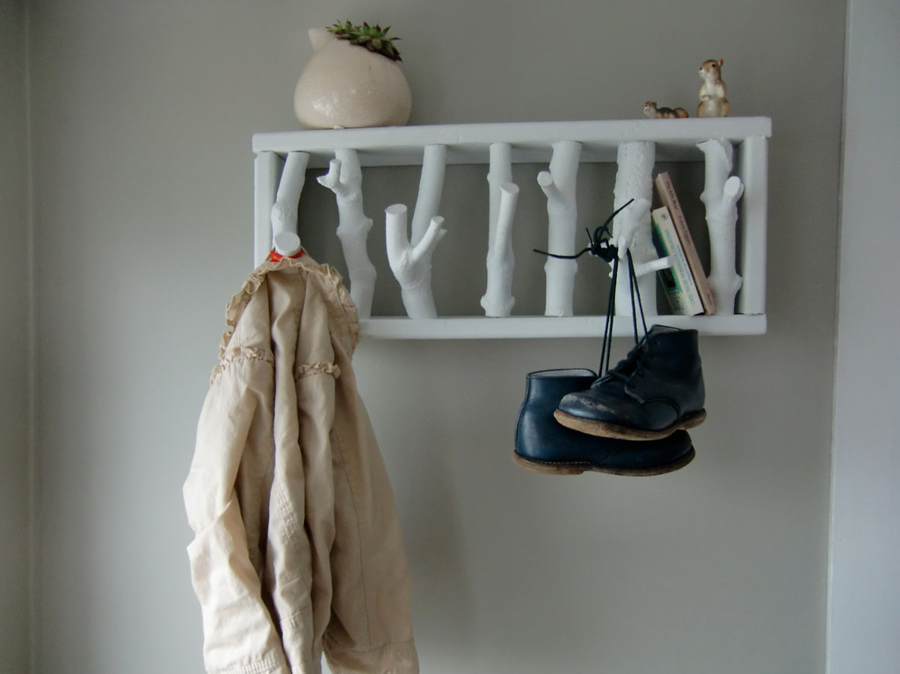
Tech Ed Design Project 2020

Design Brief: Most products in everyday use solve a problem. The process of creating something to solve a problem is called design.

Rationale: We stumble over problems every day. With effective design, we can elegantly solve these issues. An example might be a jumble of shoes by the door, a window that swings open and shouldn’t, a disorganized closet, storage for hockey sticks or bike helmets, a tree that needs a swing, or something else. Notice the things that annoy you as you go about your day. If you can’t think of anything, ask others what problems they’ve noticed.


Task: Identify a problem in your home that needs a solution. Draw solutions to the problem, obtain feedback, refine a solution. Make a technical drawing of the final version. Have the teacher check each step.

Bonus: make a prototype, or the actual piece to solve the problem!

Instructions:
Share each step on Google Classroom

Step 1: Describe the problem you noticed. Ask others if you are stuck.
Examples:
- coats pile up on the banister
- your bedroom door closes when you don’t want it to
- the dog sleeps on the blankets and doesn’t share well
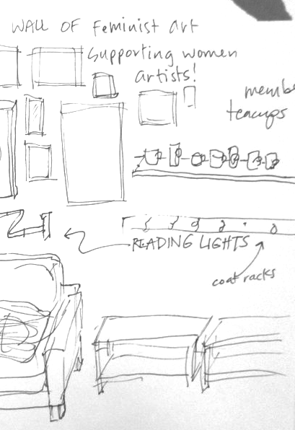
- hockey sticks fall over in the garage, etc.

Step 2: Explain limitations. These are things like how much space is available? Who will use it? How tall are those people?

Step 3: Sketch four or more different solutions to the problem. Think beyond the most basic idea – this is your chance to think of grand solutions. How can you make it fancy?
Note: Sketches are NOT clean and tidy drawings – they are a way to get your ideas down on paper in a quick way. Use sketching to depict: shape, size, how it might look, be put together, materials, such as wood, metal, nails, screws, wood glue, something else?

Step 4: Come back and add more ideas. Sometimes you need time to let your brain work. You might wake up with a great idea, or have a genius thought while folding laundry or playing a video game!

Step 6: Talk to at least one person in your house to get their perspective. What suggestions do you want to include in your design? This is good dinner table conversation!

Step 7: Revist Step 3. Reflect on your drawings. Make notes.

Step 8: Choose the design you think best solves the problem.

Step 9: Draw your design at scale by hand or using a computer assisted drafting (CAD) program. If using paper:
- Use a ruler or a straight edge to draw cleanly so it’s easy to read. This is what makes a project plan different from sketches!
- Write the real dimensions on each edge to show how big it will be if you build it.

*Note: a good scale for many household items is to measure them and draw 1 foot (in real life) to 1 inch (on paper).
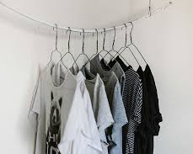

Extend this assignment:

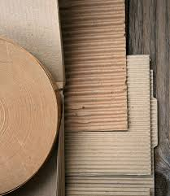
Step 1: Use cardboard, card stock, paper, tape, hot glue or any other materials you have at home to build a prototype.

Step 2: Reflect:
In what order do parts get attached?
How well does the prototype show that the problem will be solved?

Step 3: Make changes, troubleshoot, and test again until you have a prototype that works best.

Step 4: Write down the final steps you took to build your prototype - this is known as a project plan. Include:
- a list of what pieces are needed (a parts list)
- the size each piece should be cut to (a cutting list)
- the order they get attached (assembly plan)
- how you attached them (screws, glue, nails, dowel joints, butt joints, mitre joints, something else).

Stretch activities (some are a big stretch):
- Price out the materials you want to use. You might decide to also include safety glasses, drill bits, driver bits, and maybe tools you don’t yet have at home. Consider if you would use hand tools or power tools.

- Research how your project would have been made using only hand tools.
  - How would you cut material to size?
  - How would you shape your piece?
  - Would you need to also make your own connectors? Think about how nails were made and when screws were invented.
  - Would you have to learn how to connect parts using something like a mortise and tenon joint or a dovetail?
  - What techniques or methods are different than today?

Assessment Rubric:
 | Extending | Proficient | Developing | Emerging
Understanding Context
Understanding context | Student collaboratively seeks out information and ideas. Demonstrated effort in contextualizing design problem
Ideating/Defining
Defining | Problem and solution are well-defined based on context
Ideating | Many considered designs are expertly created, shared, revisited and refined.
Prototyping/Testing/Making
Prototyping | Many sketches that incorporate design ideas were developed and built upon
Testing | Designs are considered in actual space through imagery, drawing and measuring, and through the use of physical prototypes
Making | Technical drawing and/or actual item is well-created. Drawings adhere to conventions. Actual artifacts demonstrate appropriate level or stretching skills.
Sharing
Sharing | Was able to elegantly demonstrate complete design process.

BC MOE Curricular Outcomes

Grade 7
- technical drawing, including sketching techniques and manual drafting techniques
- elements of plans and drawings
- simple computer-aided drafting programs

Grade 8
- manual and computer-aided drafting techniques
- elements of technical plans and drawings
- advantages of using vector files
- virtual creation using CAD

Grade 9
- drafting technique, including dimensioning and standards
- drafting styles, including perspective, mechanical, and architectural
- CADD/CAM, CNC and 3D printing
- function of models
- basic code
- digital output devices
- virtual creation using CAD/CAM

Grade 10
- design opportunities
- drafting terminology
- drawing standards and conventions
- scales for different types of drawings
- drafting styles, including perspective, mechanical drafting, and architectural drawing
- modelling using computer-aided design (CAD) and computer-aided manufacturing (CAM) software
- coding for creating 3D representations of design solutions
- equipment and tools for manual and computer-aided drafting

