Design Activity: Recycle Project
Reusable Grocery Bag

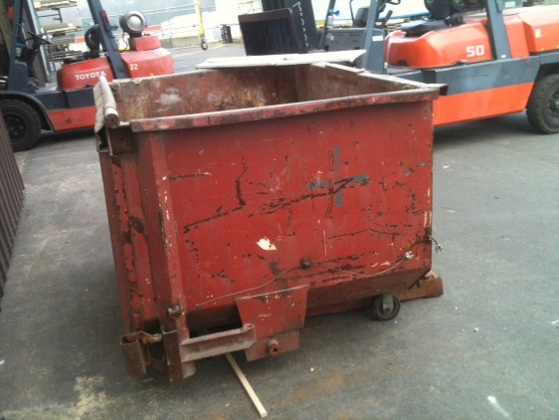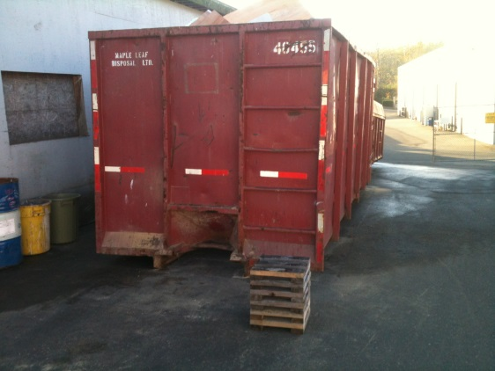
From two garbage bins at my work I pulled out nearly a hundred strands of plastic banding used for binding lifts of wood and bags also bags of insulation.
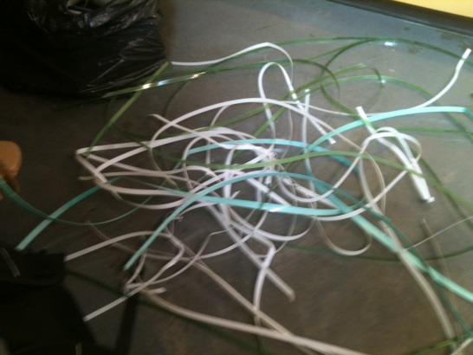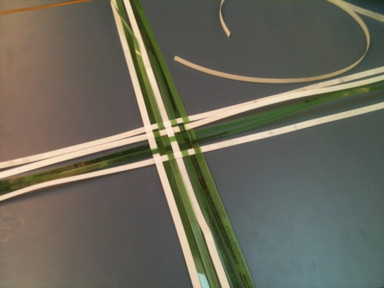
The banding ranged from approximately 10 to 15cm in width and ran anywhere from a meter to 2½ meters long. The banding is generally coloured white or different shades of green.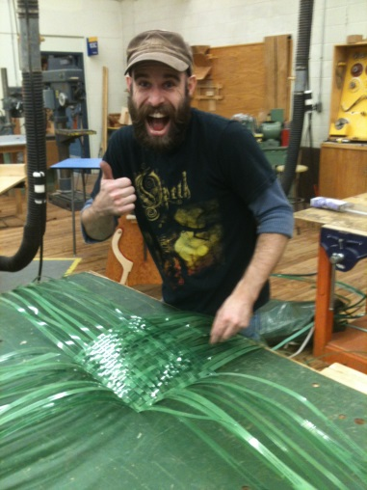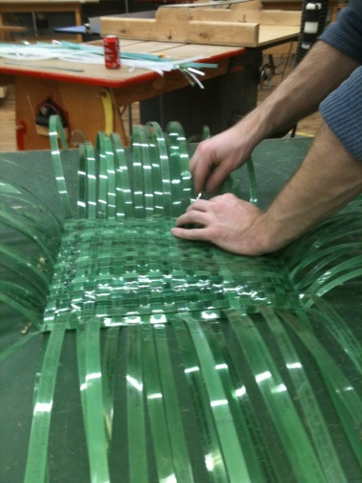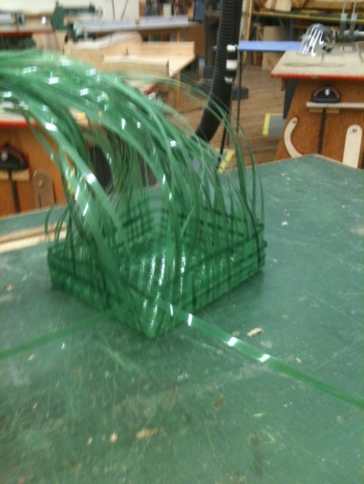
With the idea of reusability in mind I thought about the reusable fabric grocery bags. With that in mind I set out to find a way of making something like that out of the banding. After some brief thought, I realized I could weave the banding together to meet my goal of creating the bag. I have never weaved before, but I have a good understanding of how to do it. I began to weave the bottom by finding the approximate center of a handful of pieces of banding and measured out 14”. From that 14” mark out I began to weave out the bottom. After weaving the bottom I bent all the banding up and began weaving full bands around the base to make the sides.
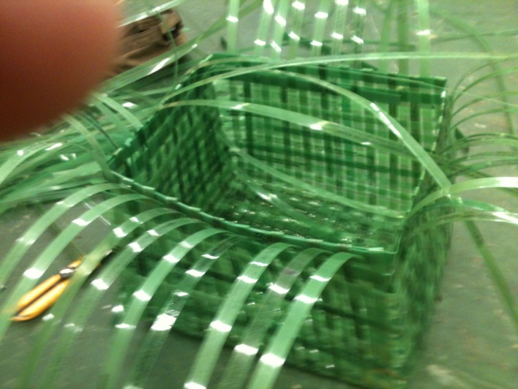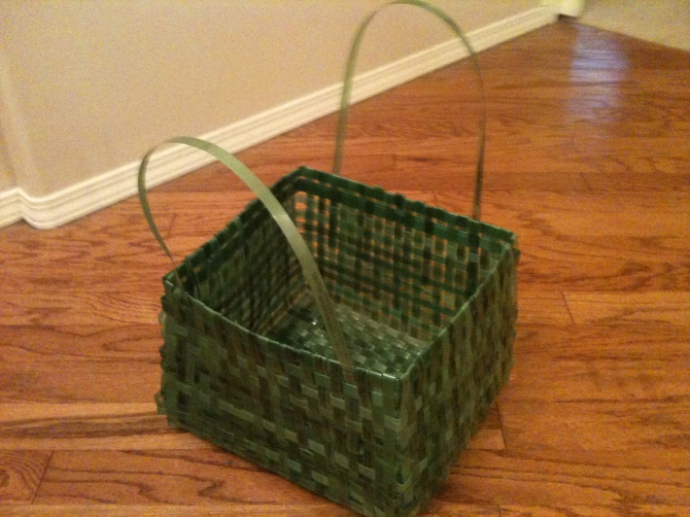
When I wove the sides up to a height I liked, I folded the extra banding over and wove it back down through the initial weaving. By weaving the extra length back down I saved myself two problems. Firstly, I had no way of binding the banding at the top so by folding it and weaving it back down I eliminated that problem. Secondly, it made the bag stronger by tightening up the weave.
I attached the handles by weaving them down through the side weaving and then folding it back up and weaving it back up. After some weight testing, I found myself sufficiently satisfied with the handles strength.
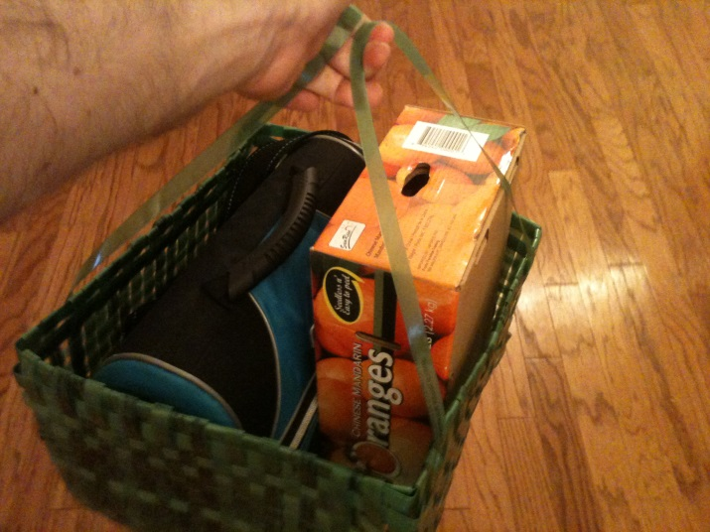
What you need to make this:
- A healthy supply of banding
- A utility knife or scissors
- Your mitts

