Circuit Card Project
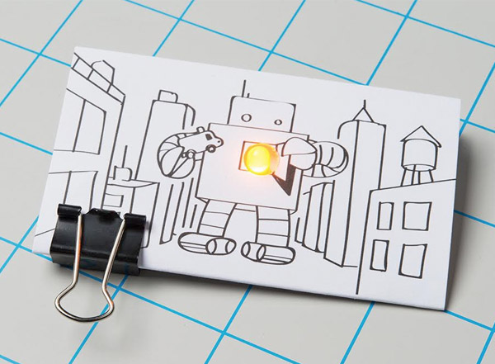
https://www.sparkfun.com/papercircuits

Content
- Electricity: a form of energy resulting from the flow of electrons through a circuit
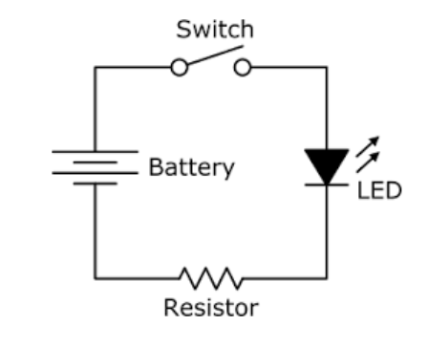
- Circuit: a pathway for electricity to follow which starts and finishes at the same place

- Electrical load: any component of a circuit that consumes power or energy (example: light, motor, etc.)
- LED (Light Emitting Diode): a light through which electricity can only flow through in one direction (positive to negative)- shorter end is negative, longer end is positive
- Parallel circuit: a circuit in which the current divides into two or more pathways before recombining to complete the circuit
- LEDs will shine with same brightness because each path receives the full circuit voltage
- The total circuit current is equal to the sum of the individual branch currents
- Series circuit: a circuit in which the current follows only one path (passing through each load)
- LEDs will shine with the same brightness as each other, decreasing in brightness with an increased number of connected lights (demonstrates a voltage drop across the circuit where the total voltage across the circuit is the sum of voltages across each load)
- The current running through each load is the same
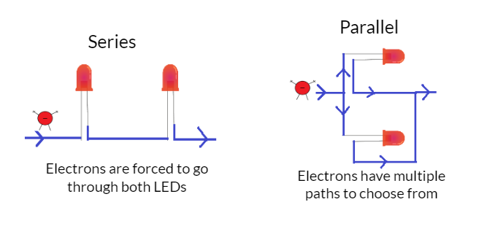

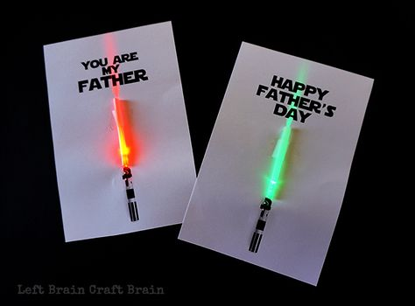
Examples

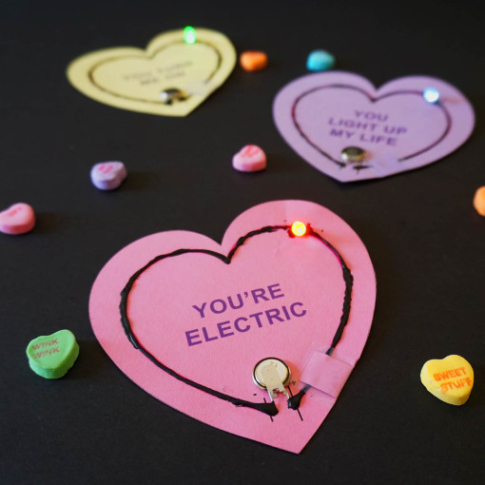
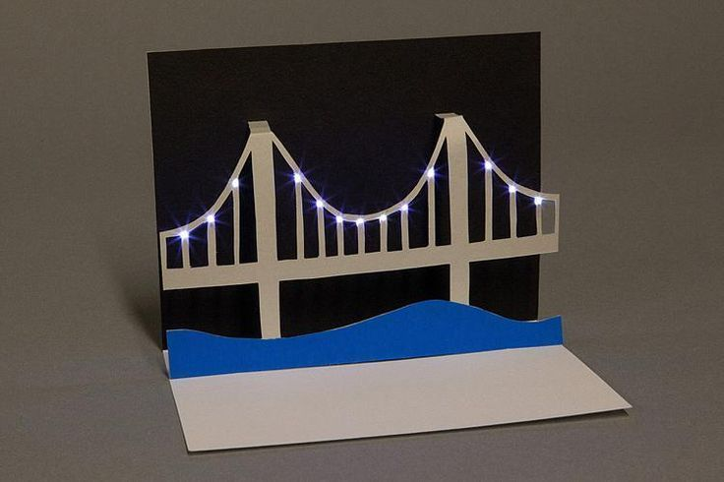

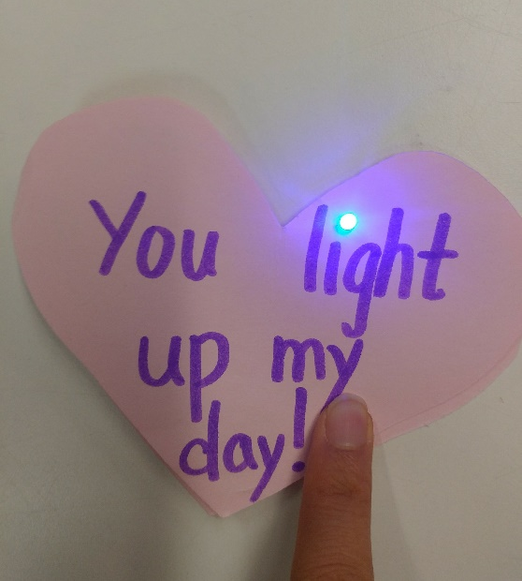
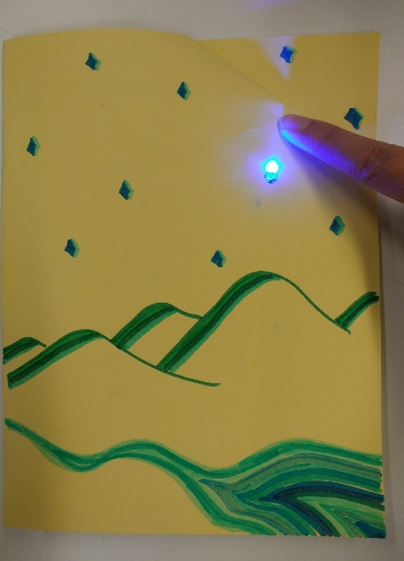

Materials
- scissors
- coloring supplies
- regular clear tape
- cardstock
- 5mm copper tape
- coin cell batteries (1/student)
- LEDs (1/student or more)

Safety
Be careful not to create a short circuit! (Short circuits occur when the battery is connected directly back to itself, which will lead to overheating and leaking battery acid).

Preparation
Cut out sections of copper tape for each student

Procedure
- Watch the video for instructions
https://www.youtube.com/watch?v=7hb-9eUpfbQ
- Refer to pictures on next page
1. Draw three ideation sketches
2. Choose one design and decorate your card
3. Place your LED where you want it to be in your design
4. Draw out where each circuit component must go to make the LED light up (draw in pencil)
5. Run copper tape from the negative (short) end of your LED to where you want to place your battery
6. Place the battery (negative end down) directly on top of the copper tape
7. Run a second piece of copper tape from the positive end of the LED which will be connected to the positive end of your battery
8. Fold the corner to make the LED light up when pressed.
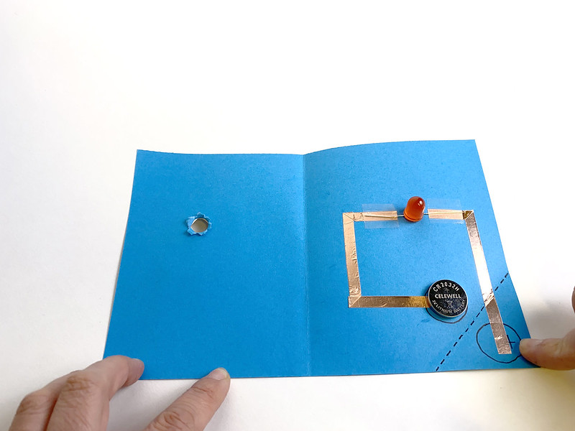

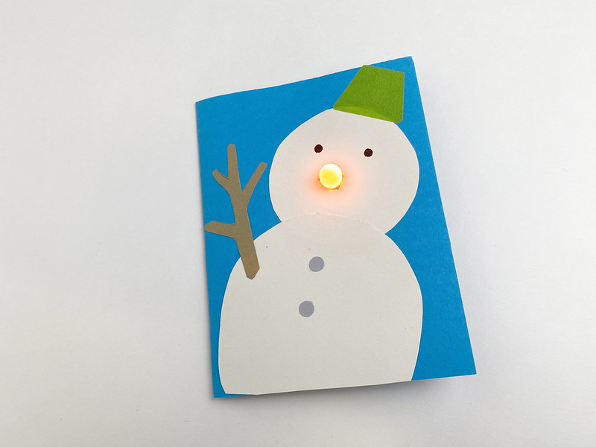

Based on work by Geering Up (UBC)
Modified by Seung Han & Ian Lee

