Design a Backyard Project

Created by Chris Schrauwen

Let’s give the bookwork a bit of a break shall we? Something I have noticed since I building things and posting them on social media once you start doing this friends, family and acquaintances will reach out to you for your services. I think this is because of two reasons; a) people want somebody doing work for them whom they can trust. b) People like supporting those they know.

This is the scenario you may find yourself in soon, so why not do an assignment that prepares you for this. Cathy and Bill from down the street recently saw that you brought home this sweet looking cutting board from Summerland Secondary, or for the senior students in the class, these beautifully machined oak parts which you did have time to assemble because of the Covid-19 pandemic. This is very exciting news for you because not only are Cathy and Bill letting you build what you want but they also have no budget, they’re crazy rich! Cathy invented training wheels on children’s bicycles, before this kids would just fall all of the time, leading parents to accumulate high medical bills.

What Cathy and Bill are asking for is for you to make a design something for their backyard that will become a centrepiece to the area, your project is something that the homeowners and guests will notice the moment they enter into your backyard.

The clients have a few stipulations they have asked of you when coming up with your design.

- The project needs to be something useful. For example, they wouldn’t be happy with an 8ft tall carved statue of your favorite Fortnite character, that can’t be useful for anything, except for maybe getting under your neighbours skin. However, a unique outdoor garden planter would make them happy.
- It cannot exceed 12ft in any dimension (length, width, height, depth.)
- It will be outside all year, so the correct material needs to be chosen for a South Okanagan climate.
- It can include other non-wood based materials but wood needs to be the main material.
- They want an area on your project where they can grow some small plants.
- They have communicated to you that they would be extra happy if there was an area for them to sit and gaze at the birds. Hmmm…maybe they will give me a bonus if I were to include this into my design.

What you will need to hand into me:

- 8 ideation (idea) sketches of what you are planning to design. Due May 18th

- A 3-view orthographic drawing of your project. Include dimensions and any necessary details into your drawing as if I were to build and replicate your idea without having to contact you about the details. I also want a picture of an example as to where your inspiration came from, this could be a picture of the internet, a book, magazine etc... Due may 25th

- Complete a rough estimate of the cost of the project for your client. Include an hourly wage which you plan to pay yourself, the estimated time it would take to build this project, and rough estimate of your materials cost. ***Use all prices for materials from www.homedepot.ca *** Due June 1st

Backyard Project Examples:
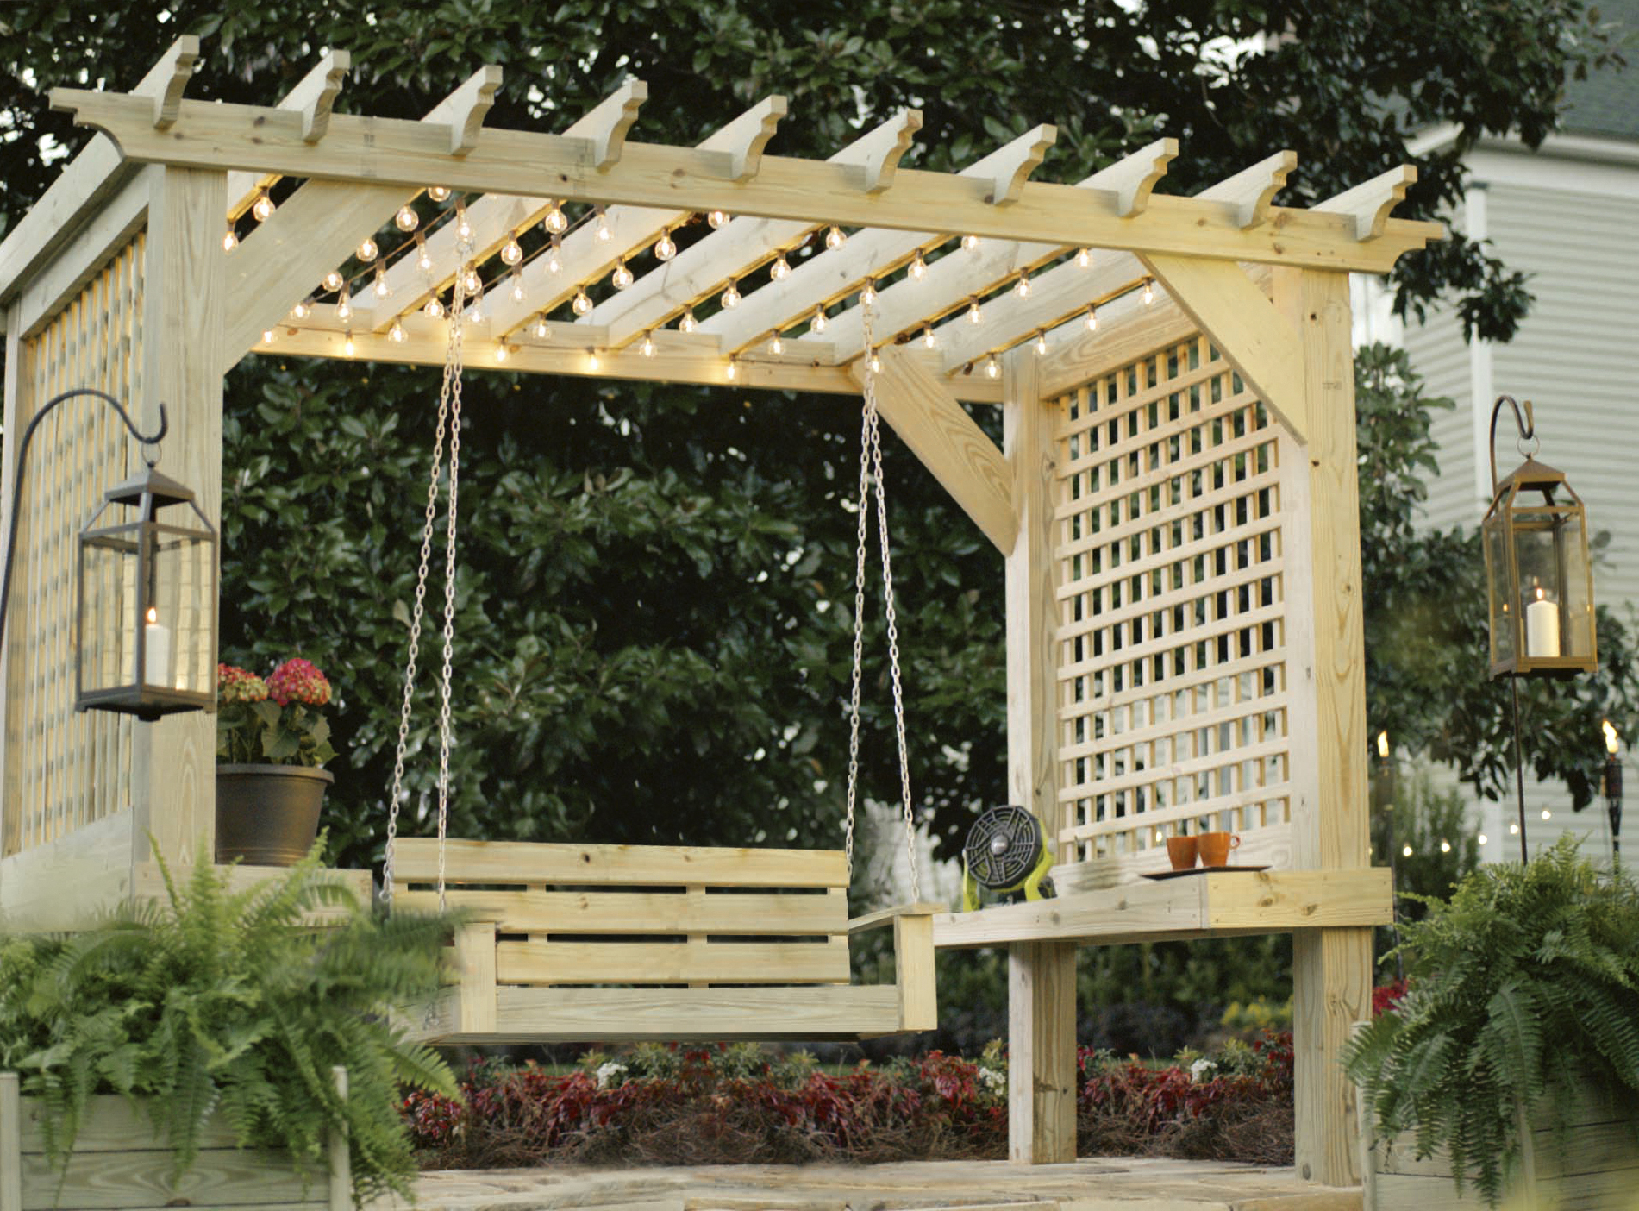

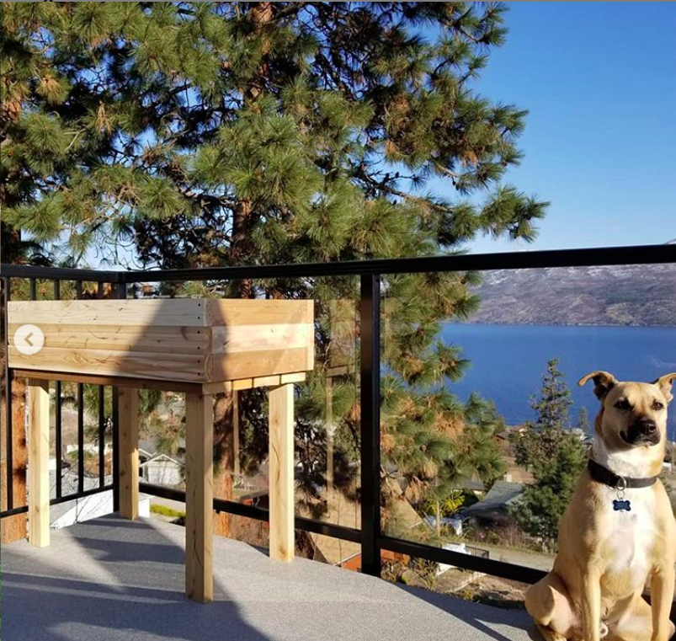
Pergolas are popular in backyard designs these days, they provide small amounts of shade cover and privacy from surrounding neighbours. The swing would be a great place to enjoy a morning coffee or read a book.
That’s my dog, claiming ownership of this planter I built for my deck. I resawed a bunch of old cedar on the table-saw which became weathered over time.
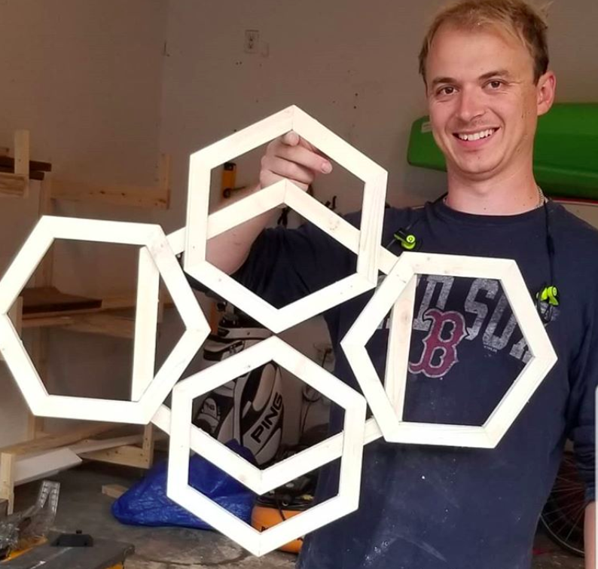
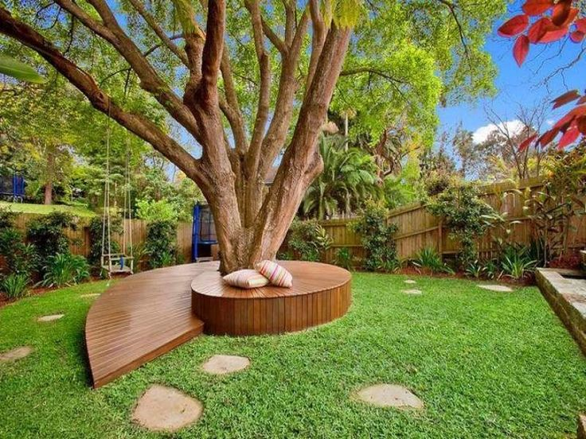
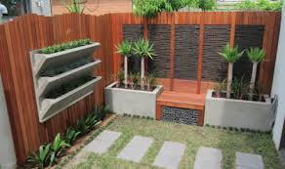
This would not be an acceptable design to create for your clients. There is no use to it, it is strictly art work with no purpose other than to gaze at. Also, don’t forget I am asking you to design something that could help plants grow.
This individual used a combination of concrete as well as stained cedar which balances itself really well. There is a lot of function to this design, with the bench seat in the middle and the fencing surrounding the project, it acts as a privacy space which is which could important to individuals living in close quarters to their neighbours.
I almost didn’t include this because I couldn’t see a clear function to the design. But I feel now that the function would probably be a lounge area for residents and guests of the house. The would have been a tricky build and as the tree grows it may have to be removed. But this involves that aspect I hope to see with your design as this project now becomes the “centrepiece” of the backyard.

