

Digital Accessibility Worksheet
for CACUSS 2021

Work your way through the following exercises to practice your digital accessibility skills. Feel free to work as a group, and ask other group members clarifying questions. Please bring any questions the group has back to the session Q&A. An answer sheet can be found in the files section of this CACUSS session.

Text

Descriptive text
Rewrite each of the following sentences so that the hyperlink (the underlined text in blue) is written using descriptive text.
Note: There is often more than one way to change a sentence so that a hyperlink uses descriptive text. The ‘answers’ below are just examples!
- To change your registration status or cancel your registration, click here.
  - OPTION: If needed, you can change your registration status or cancel your registration.
- Orientation will take place on Sept. 3 and 4 this fall. Learn more.
  - OPTION: Orientation will take place on Sept. 3 and 4 this fall.
- To register for an advising appointment, access the appointment calendar via the ClockWork platform.
  - OPTION A: To register for an advising appointment, access the appointment calendar via the ClockWork platform.
  - OPTION B: To register for an advising appointment, access the appointment calendar via the ClockWork platform.
- Students can purchase a discounted gym membership for the entire school year, or just for a term. Click here to find membership prices for 2021-22.
  - OPTION: Student can purchase a discounted gym membership for the entire school year, or just for a term.
- Due to current health restrictions, the university has made changes to the available study space on campus. You can find more information here.
  - OPTION: Due to current health restrictions, the university has made changes to the available study space on campus.

Knowledge check
- For each of the following, indicate whether the statement is true or false (bonus points if you can explain why!):
  - You should never use an asterisk (*) to create a list.
    - True. Using the list functions provided by an editor will ensure they will be read as lists by a screen reader.
  - Hyperlinks should be set to open in a new window.
    - False. Hyperlinks should open in the same window, although there are a few exceptions, such as links on a form someone is filling out, or links from within a password protected area that would take you to a non-password protected space.
  - Large paragraphs of text should never be centred.
    - True. Centering a large paragraph of text makes it harder to the eye to track and skim the text.
  - Always write out the full URL for a link.
    - False. Hyperlinks should be provided using descriptive text, not the full URL.
  - When using headings in a document or on a webpage, never skip heading levels.
    - True. This can lead a reader to believe they have missed content.

- When writing slide titles for your upcoming presentation, they should be written in (bonus points if you can explain why!):
  - All upper case
  - Sentence case. Upper case letters are less distinguishable from one another, as they all take a block-like shape, and can therefore be harder to read.
  - All lower case
- If you are creating a hyperlink for a PDF version of an event schedule, which of the following would be the most appropriate hyperlink?
  - Click here to check the event schedule for more details
  - Check the event schedule for more details
  - Check the event schedule (PDF) for more details
  - Check the event schedule (PDF 126 KB) for more details. Hyperlinks should always be written using descriptive text. If the link goes to a non-HTML item (such as a PDF), the item type, and size of the item, should be indicated within the descriptive text.

Images

Alternative text
For each of the following images, draft alternative text. Remember, alt text is subjective, and contextual! There’s not one “correct alt text” for an image.

Photo by Yaroslav Muzychenko on Unsplash
Alt-text: A fire-truck turning the corner at a car-free intersection.

Photo by Sri Gowda on Unsplash
Alt-text: A person stands on the corner of a dock in a lake surround by mountains and trees. Many purple and orange canoes are tied to and lined up on the dock.

Photo by Kelly Sikkema on Unsplash
Alt-text: A man wearing glasses holds a small smiling child in his arms and kisses him on the cheek.

Video & Audio

Knowledge check
Which of the following scenarios could cause an accessibility issue?
- During a Career Services workshop, the presenter plays a video demonstrating how to give an elevator pitch without turning on the captions. Always display the captions when playing a video for an audience. This will help students who are hard of hearing, and can also help students for whom English is a second language.
- A professor is recording a video lecture in which they are writing on a whiteboard without narrating what is being written. Without narrating what is being written on the whiteboard, that content will be inaccessible to a blind or visually impaired student watching the video.
- In a podcast interview for your institution’s student life podcast, the interviewer describes the hand gestures the guest has made that are making them laugh.
- A student must click on a video on your website to make it play.
- The volume on the welcome video from your president varies as they switch between different locations. If the volume in a video is fluctuating, it can cause problems for a deaf or hard-of-hearing student. It’s also annoying for everyone!

Social media

Social media posts
For each of the following social media posts, identify any accessibility issues.
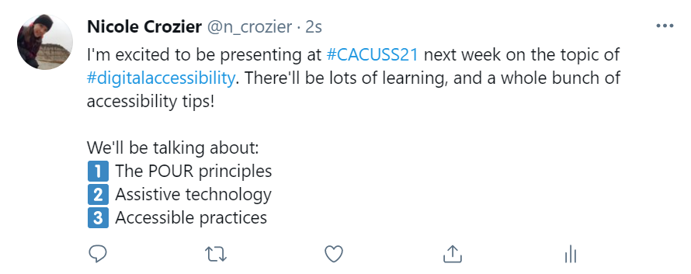

ANSWER:
- Hashtags should be written using camel case, capitalizing the first letter in each word (e.g. #DigitalAccessibility).
- Emojis should be used carefully, and should not be used to create a list. In this case, the emoji description that would be read by a screen reader would be “keyword digit one.”

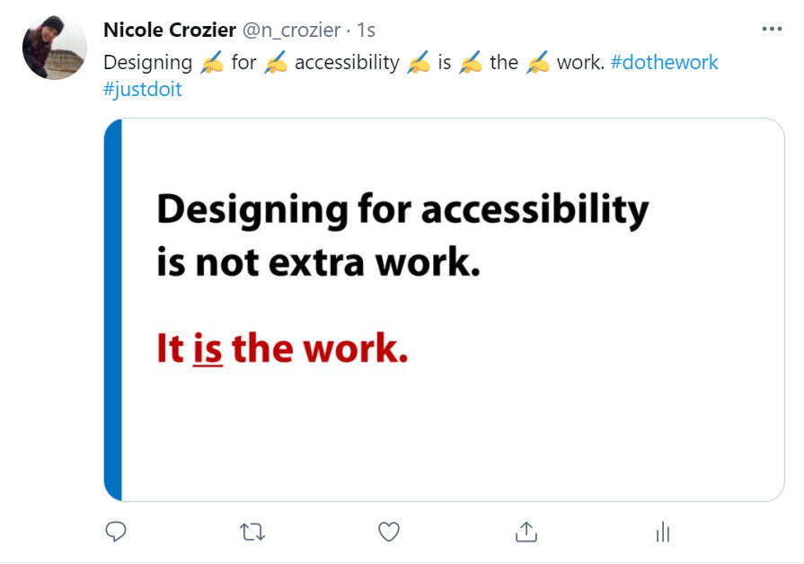
- Hashtags should be written using camel case, capitalizing the first letter in each word (e.g. #DoTheWork, #JustDoIt).
- Emojis should be used carefully, and should not be placed in the middle of a sentence.
- Be careful using flattened text on images, as it cannot be read using a screen reader. Images should always have alternative text, and that text should describe the words on the image.

Knowledge check
True or false:
- Emoji should never be used on social media, because they are inaccessible to screen readers.
  - False. All emojis have a description associated with them, and that description will be read by a screen reader. Emojis can be used on social media, but use them with care!
- Images on social media are automatically given alt text, so you don’t need to worry about it.
  - False. Images are rarely automatically given alt text. In cases where they are, the automatically generated alt text is typically subpar, so you should always write your own.
- Hashtags should always be written in camel case.
  - True. This makes it possible for a screen reader to read, and makes it easier to everyone.
- All videos posted on social media (including Instagram stories and reels) should be captioned.
  - True. Captioning social media videos makes them accessible to those who are hard of hearing. It also makes them accessible to folks who are in a public location and cannot turn on sound.
- Text written on an image can be read by a screen reader.
  - False. A screen reader cannot read text on an image. Text on images should be used sparingly, and should also be included in the social media post, accessible on a website you link to, and/or include in the alt text.

Colour contrast

Using a colour contrast checker, determine whether each of the following text boxes are accessible. Note: The answer key assumes we are testing normal text at the WCAG AA level.
Foreground (text): #000000 Background: #ED7C31
Yes!
Foreground (text): #FFBF00 Background: #385723
Yes.
Foreground (text): #00B0F0 Background: #0000FF
No.
Foreground (text): #00B04F Background: #FF0000
No. Never use red on green!
Foreground (text): #FF99FF Background: #9999FF
Nope!

